Non-destructive Testing of Airfoil Based on Infrared Lock-in Thermography

Chunqiang Bo, Hong Hu\*, Ze Liu, Guobin Lei and Junhao Shao

*Harbin Institute of Technology Shenzhen Graduate School*

*Shenzhen, 518055, China*

honghu@hit.edu.cn

***Abstract -* As the main material for aircraft airfoils, Carbon fiber reinforced plastic (CFRP) will inevitably have some defects that are produced in the manufacturing process. One of the more serious defects is delamination, for which nondestructive testing has become an obstacle to its continued development in the aviation field. This paper therefore uses CFRP as the specimen and double-layer Teflon film as the defect to simulate delamination. Through simulation analysis, the phase difference between defective and healthy areas are studied along with the influence of defect diameter, depth and heat flux frequency. Based on lock-in thermography technology, the image sequences of the specimen are post-processed by both the Fourier transform method and the principal component analysis method. Finally, the position and diameter of defects are quantitatively studied based on the extreme values and the first derivative, and the reason for errors is analyzed.**

Index Terms - CFRP; Lock-in thermography; NDT

# Introduction

Composite materials comprising carbon fiber reinforced polymer (CFRP) and glass fiber reinforced polymer (GFRP) are widely used in aerospace, renewable energy, civil engineering, and other industrial fields [1]. Fig. 1 shows the material composition of the Boeing 787 [2]. Since most of the material in the airfoil is carbon fiber-based composite material, CFRP was selected as the object of this research.

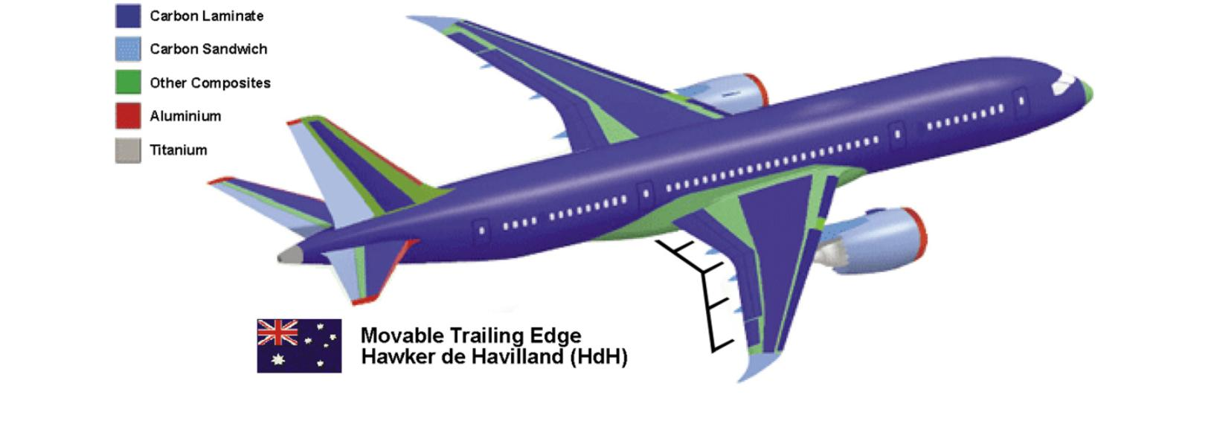

Fig. 1 Material composition of the Boeing 787

Due to factors such as resin viscosity and differences in thermal expansion coefficient, delamination, debonding, stoma and other defects often occur in CFRP products. Delamination is the most common among these defects. However, research on non-destructive testing (NDT) of CFRP is lagging and has become a major obstacle to the development of CFRP in the aviation field.

Li et al. [3] and Liang et al. [4] detected CFRP defects after low-velocity impacts by infrared thermography and eddy current pulsed thermography. Zheng et al. [5] used pulsed thermography (PT) and thermographic signal reconstruction (TSR) to study CFRP defects. Shrestha et al. [6] embedded copper sheet in the sample as the defect and used the Fourier transform method for post processing. Liu et al. [7] proposed a time constant method, while Gong et al. [8] used artificial flat-bottomed holes as the implanted defect and cross correlation for assessing the defect.

Most researchers currently use PT for infrared NDT, simulating the delamination defect by artificial flat-bottomed holes or by embedding a metal piece in the sample. With the aim of providing a better alternative, this paper studies the simulated defect of double-layer Teflon film based on lock-in thermography. This means that the specimen is loaded with a periodically changing heat source where image sequences are recorded by infrared camera and data reconstruction is realized by digital lock-in technology. This paper uses simulation analysis to study the influence of defect size, depth and heat source frequency. According to the simulation results, NDT of the specimen was performed based on the idea of image sequence. Experiments show that this method is effective and can accurately determine the location and size of defects.

# Simulation

The basic principle of infrared NDT is Stephen-Boltzmann's law: for a general gray body, its radiation intensity W can be expressed as:



Where represents gray body emission coefficient, represents Stefan Boltzmann constant, , and represents absolute temperature.

Stephen-Boltzmann's law shows that if an object is above the absolute temperature, infrared radiation will be generated due to its own molecular motion, and the infrared camera can accurately record it. Heat conduction is the main mode of heat transfer. It refers to the way the heat on the specimen surface conducts to the inside of the specimen, and it always conducts from high temperature to low temperature. The function for heat conduction is:



Where represents the density of heat flow (), and represents thermal conductivity ().

Common defects such as cracks, stoma and delamination are all thermal insulation defects. If there is a thermal insulation defect inside the object, when the single-sided detection method is adopted the defect will show a high temperature point due to heat accumulation. Conversely, with the double-sided detection method it will show a low temperature point.

Fig. 2 (a) shows the actual size of the specimen. It is made up of 7 layers of carbon fiber fabric, measuring 250 mm long, 200 mm wide and 1.26 mm thick.

Fig. 2 (b) is a metallographic image of the specimen under a microscope. It can be seen that this specimen is formed by stacking carbon fiber fabrics perpendicular to each other at 0°and 90°angles. According to the statistics, the average thickness of a single layer of carbon fiber board is 0.18mm.

|  |  |
| --- | --- |
| C:\Users\Administrator\Desktop\论文\论文用图\仿真\1526362952756-1ea65424-53bb-4a96-86b4-48388a1dd03.jpg  (a) Specimen | C:\Users\Administrator\Desktop\论文\复合材料超声C扫\金相.JPG  (b) Metallographic |

Fig. 2 Specimen and its metallographic

Fig. 3 shows the specific location of the defects. Just as in the manufacturing process, it is difficult to make air gaps in the specimen with guaranteed dimensions. Therefore, in order to simulate CFRP delamination defects, four double-layer Teflon films (single-layer Teflon film is 0.05mm thick) were embedded in the second, fourth, and sixth layers (depths of 0.18mm, 0.54mm, and 0.9mm), with diameters of 12mm, 9mm, 6mm, and 4mm respectively. For ease of description, these defects are numbered 1-12 from top to bottom, left to right.

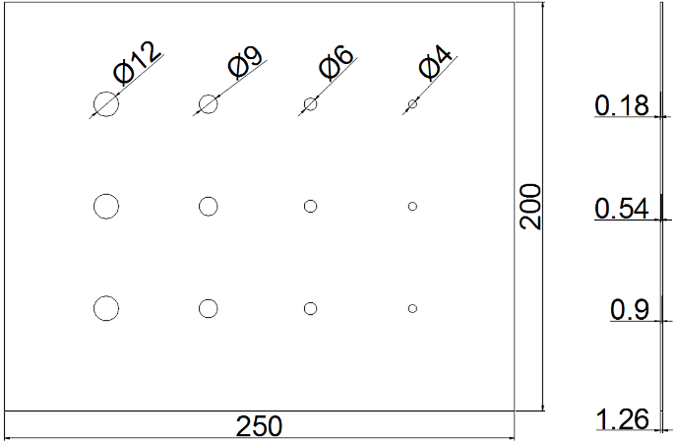

Fig. 3 Specific location of the defects

The 3d model in this paper is completely constructed according to the seven-layer structure of the specimen and it uses a finite element method for simulation. Considering that CFRP thermal conductivity is small, the heat balance is relatively slow, and the steady-state time is long, the transient analysis method is used in this paper. This will not only save time, but will also avoid damage to the specimen caused by high temperatures.

Considering that it is impossible to apply a negative heat source to the specimen, the heat flux loading equation is given as:

(3)

TABLE I shows the thermal properties of CFRP and Teflon. Fig. 4 shows the surface temperature rise curve of the number one defect when the heat flux frequency is at 0.1Hz. As there is an overlay of a sine curve and a trend term, in order to accurately obtain the phase difference change trend the influence of the trend item should be removed.

C:\Users\Administrator\Desktop\论文\论文用图\仿真\温升曲线.wmf

Fig. 4 Surface temperature rise curve

TABLE I Thermal Properties of Cfrp and Teflon

|  |  |  |
| --- | --- | --- |
|  | CFRP | Teflon |
| Density () | 1652 | 1100 |
| Specific () | 1411 | 2150 |
| Thermal conductivity  () |  | 0.209 |

The first, second, and third order fitting eliminations of the temperature-rise curves are performed using the least-squares method. The results in Fig. 5 show that the second order curve fitting to eliminate trend terms is the best. Therefore, when using the least squares method to eliminate term trend, it is not advisable to blindly pursue high-order fitting.

C:\Users\Administrator\Desktop\论文\论文用图\仿真\三阶消除.wmf

Fig. 5 Trend term elimination

The phase difference is the difference between the defective and healthy areas. In this paper, the phase value of the defect center is used as the defective area phase value, and the phase value of the area surrounding the defect is used as the healthy area phase value.

(4)

Where represents the defective area phase, and represents the healthy area phase.

Fig. 6 (a) shows the phase difference trend of different diameter defects under different frequency heat source excitations at the same depth (0.18mm). It can be seen that the variation has same trend of the phase difference for different diameter defects, and the maximum phase difference occurs near the same excitation frequency. Moreover, as the diameter of the defect decreases, the variation trend of the phase difference tends to be gentler and the maximum phase difference is smaller.

Fig. 6 (b) shows the phase difference trend of different depths of the defect under different frequency heat source excitations with the same diameter (12mm). It can be seen that as the depth of the defect increases, the phase difference changes less and less, and the defects with a depth of 0.9 mm are less sensitive to variations in excitation frequency. In addition, the excitation frequency of the maximum phase difference also changes with the defect depth.

C:\Users\Administrator\Desktop\新建文件夹 (2)\A.wmf

Fig. 6 (a) Phase difference trend of different diameters

C:\Users\Administrator\Desktop\新建文件夹 (2)\B.wmf

Fig. 6 (b) Phase difference trend of different depths

From the simulation results, we can arrive at the following conclusions:

1. The larger the defect size, the shallower the depth, the higher the sensitivity of the detection, and the easier the defect is to be detected.
2. As the defect depth increases, the defect will no longer be sensitive to the heat flux frequency, and the effect of infrared NDT will deteriorate.
3. Defect depth is more significant for testing than defect size.

# Image Processing

1. *Image Preprocessing*

Like other technologies, infrared NDT is also disturbed by various factors. These factors can be roughly attributed to three types: (1) detection system hardware factors, such as system noise and infrared camera noise; (2) environmental factors, such as uneven heating of the specimen and environmental radiation; (3) specimen factors, such as materials surface emissivity and defect types.

For example, uneven heating of thermal images will greatly reduce the accuracy of algorithm detection [9]. Therefore, in order to eliminate irrelevant information in the image, reduce the noise, improve the signal-to-noise ratio, and increase the accuracy of image processing, image preprocessing is absolutely necessary.

This paper selects two linear filters (Gaussian filter and mean filter) and one nonlinear filter (median filter) to process the image with the same size (size=5). And the image quality is evaluated using Peak Signal to Noise Ratio (PSNR) and Structural Similarity (SSIM). PSNR is the most widely used objective measurement method. Its disadvantage is that it does not reflect people's subjective feelings well. Though SSIM has a more complex calculation, it can reflect people's subjective feelings better. The evaluation results of the two methods are shown in Fig. 7. Based on the evaluation results, the Gaussian filter is selected as the image preprocessing method in this paper.

C:\Users\Administrator\Desktop\滤波.wmf

Fig. 7 Evaluation results of three filters

|  |  |
| --- | --- |
| C:\Users\Administrator\Desktop\伪彩色\1.png  (a) 1st frame image | C:\Users\Administrator\Desktop\伪彩色\251.png  (b) 251st frame image |
| C:\Users\Administrator\Desktop\伪彩色\501.png  (c) 501st frame image | C:\Users\Administrator\Desktop\伪彩色\751.png  (d) 751st frame image |

Fig. 8 Origin image

1. *Difference Method*

The difference operation mainly utilizes the difference in heat conduction properties between the defective and healthy areas. This difference causes heat accumulation in the defective and healthy areas. Since each frame of the thermal image records the instantaneous temperature field, static factors such as uneven heat source incidence are added to each frame of the image. Difference operation can eliminate static effects and highlight defects. The specific equation is:

(5)

In order to reduce noise interference, this paper adopts the multi-frame accumulation average method. The method adds the gray values of the corresponding pixels of two frames or multiple frames images, obtains their time average images and improves the signal-to-noise ratio. The specific equation is:

(6)

(7)

Fig. 9 (a) is the thermal image of 155th frame, and (b) is the difference image of the 151st-155th frame images and the 51st-55th frame images after using multi-frame accumulation average method. It can be seen that combining the multi-frame accumulation average method with the difference method not only significantly eliminates the influence of uneven heating, but also obtains the variation of the temperature field and highlights the defective area.

|  |  |
| --- | --- |
| (a) 155th frame image | C:\Users\Administrator\Desktop\伪彩色\sub.png  (b) Difference image |

Fig. 9 Difference method

1. *Fourier Transformation (FT)*

One-dimensional Fourier transformation is the decomposition of the time domain signals into the sum of sine functions (or cosine functions) of different frequencies. The image can be regarded as a two-dimensional signal, and a two-dimensional Fourier transformation can be viewed as a superposition of a one-dimensional Fourier transformation on each row and column scan line. Fourier transformation provides a way from the spatial domain to the frequency domain. The image can be transformed from a gray value distribution to a frequency distribution to observe the image features [10,11]. Through Fourier transformation, the corresponding amplitude image and phase image can be obtained. The specific equation is:

(8)

(9)

(10)

(11)

Fig. 10 shows the amplitude image and phase image obtained by Fourier transformation. It can be seen that the amplitude image contains part of the defect information, and the effects of uneven heating can be significantly observed. Compared with the amplitude image, the phase image contains more information. Phase image can not only clearly show all the defects, but also effectively eliminate the impact of uneven heating.

|  |  |
| --- | --- |
| C:\Users\Administrator\Desktop\伪彩色\am.png  (a) Amplitude image | C:\Users\Administrator\Desktop\伪彩色\ph.png  (b) Phase image |

Fig. 10 Fourier transformation method

1. *Principal Component Analysis (PCA)*

PCA is an effective method in mathematical statistics analysis. This method determines the most "primary" elements through data dimension reduction, which can eliminate the correlation between specimens, realize the data compression of the specimens, and eliminate redundancy. PCA can be divided into the following steps: (1) For a data set matrix of size, subtract the average of its row vectors to get a new matrix and do a normalization process; (2) Find the covariance matrix of the data and arrange all its eigenvalues and eigenvectors in order; (3) Select characteristic signals to satisfy equation (12); (4) The first n principal components are extracted as feature signals and reconstructed as original data [12,13].

(12)

|  |  |
| --- | --- |
| C:\Users\Administrator\Desktop\伪彩色\一主元.png  (a) First principal image | (b) Second principal image |

Fig. 11 PCA method

Fig. 11 shows the first principal component image and the second principal component image obtained by applying the PCA method to multi-frame continuous thermal images. It can be seen that the first principal component image mainly contains CFRP internal defect information, and the second principal component image mainly contains image background information. Reconstructing the image sequence with PCA not only reduces the influence of uneven heating and enhances the display effect of defects, but also retains the information related to depth and time of the defects, which is favorable for subsequent defect identification and quantitative analysis.

# Experiment

## Experimental Environment and Platform

The experimental platform is divided into hardware system and software system. The hardware system includes a computer processing system, a high-resolution infrared camera, and a thermal excitation system. The software system includes an image acquisition system, an image processing system and a management system. The experimental platform is shown in Fig.12.

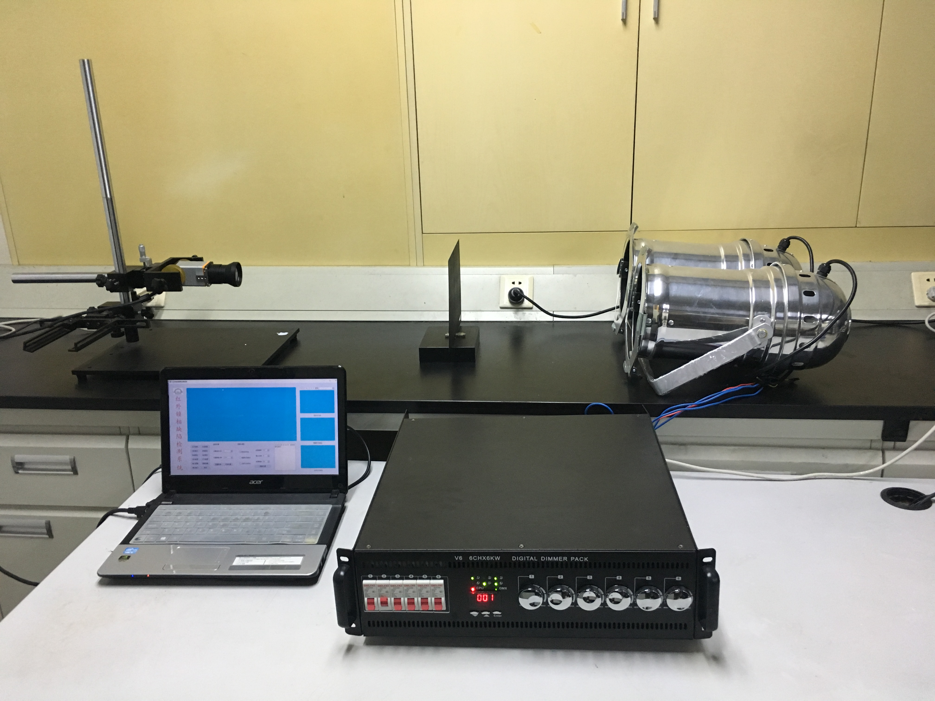

Fig. 12 Experimental platform

Whereas single-sided detection is suitable for detecting complex geometric objects, double-sided detection has high thermal sensitivity and is suitable for materials with poor thermal conductivity. Therefore, the experiment adopts the double-sided detection method and applies a layer of easy-scrubbing and thin coating on the surface of the specimen, which can effectively reduce the influence of the emissivity and enhance the energy absorption rate of the heat source and the infrared emissivity of the specimen surface.

## Experiment Results

The specimen with length of 250 mm and width of 200 mm has an image size of 517 pixels × 412 pixels, and the pixel calibration value is obtained accordingly. The specific content is shown in TABLE II.

TABLE Ⅱ Calibration of Pixel Equivalent

|  |  |  |
| --- | --- | --- |
| Specimen | Image | [Calibration](javascript:;) |
| 250 mm | 517 pixel | 0.4836 mm/pixel |
| 200 mm | 412 pixel | 0.4854 mm/pixel |

Fig. 13 (a) shows the 3D display of the first principal image, (b) and (c) respectively show the gray value and the derivative curve of the defects in the second row and the first column of the first principal component image obtained by the PCA method. By observing, whether it is a row defect or a column defect, there is a peak corresponding to the defect (a place where the gray value rises sharply). The highest gray value is the center of the defect, and the size of the defect is not easily judged. Therefore, in order to better observe the size of the defect, the derivative curve of the gray value is plotted. It is clear that the defect center originally represented by the peak has a derivative value of 0; and where the gray level changes rapidly is the edge of the defect. So the size of the defect is the distance from the peak to the adjacent trough of the derivative curve.



Fig. 13 (a) 3D display of first principal image

C:\Users\Administrator\Desktop\横坐标灰度.wmf

Fig. 13 (b) Gray value and derivative curve of the defects in the second row

C:\Users\Administrator\Desktop\纵坐标灰度.wmf

Fig. 13 (c) Gray values and derivative curve of defects in the first column

Tables Ⅲ and Tables IV show the defect position, size and the error according to Fig. 12. It can be seen that the experiment can accurately determine the center of the defect. However, for the defect diameter, especially for smaller defects, the experimental judgment error is relatively large.

## Analysis of Results

In this paper, ultrasonic flaw detection method was used to verify the defects as shown in Fig. 14. It was found that during the manufacturing process, due to the influence of the preparation technology, dislocations and folds occurred between some of the Teflon. Therefore, both the experimental measurement error and the error of the specimen preparation are the reasons for the large errors in small size defects.

TABLE Ⅲ Defect Position and Error

|  |  |  |  |  |  |
| --- | --- | --- | --- | --- | --- |
|  | Coordinate | X | Error | Y | Error |
| 1 | （50,50） | 50.77 | 1.55 % | 51.46 | 2.91 % |
| 2 | （100,50） | 100.10 | 0.10 % | 51.94 | 3.88 % |
| 3 | （150,50） | 149.42 | 0.39 % | 50.97 | 1.94 % |
| 4 | （200,50） | 198.74 | 0.63 % | 50 | 0 |
| 5 | （50,100） | 50.77 | 1.55 % | 101.46 | 1.46 % |
| 6 | （100,100） | 99.61 | 0.39 % | 100.97 | 0.97 % |
| 7 | （150,100） | 149.90 | 0.06 % | 100 | 0 |
| 8 | （200,100） | 199.71 | 0.15 % | 99.51 | 0.49 % |
| 9 | （50,150） | 50.29 | 0.58 % | 151.46 | 0.97 % |
| 10 | （100,150） | 100.10 | 0.10 % | 150.97 | 0.65 % |
| 11 | （150,150） | 150.87 | 0.58 % | 150 | 0 |
| 12 | （200,150） | 201.19 | 0.10 % | 150.49 | 0.32 % |

TABLE Ⅳ Defect Size and Error

|  |  |  |  |
| --- | --- | --- | --- |
|  | Theoretical | Actual | Error |
| 1 | 12 | 11.65 | 2.91 % |
| 2 | 9 | 9.22 | 2.48 % |
| 3 | 6 | 6.80 | 12.27 % |
| 4 | 4 | 4.35 | 8.85 % |
| 5 | 12 | 12.14 | 1.13 % |
| 6 | 9 | 9.19 | 2.08 % |
| 7 | 6 | 5.80 | 3.29 % |
| 8 | 4 | 4.84 | 20.89 % |
| 9 | 12 | 11.65 | 2.91 % |
| 10 | 9 | 9.22 | 2.48 % |
| 11 | 6 | 5.83 | 2.91 % |
| 12 | 4 | 4.85 | 21.36 % |

|  |  |  |  |
| --- | --- | --- | --- |
| C:\Users\Administrator\Desktop\论文\论文用图\结果\4_看图王.png  (a) Defect with 4 mm | | C:\Users\Administrator\Desktop\论文\论文用图\结果\6_看图王.png  (b) Defect with 6 mm | |
| C:\Users\Administrator\Desktop\论文\论文用图\结果\9_看图王.png  (c) Defect with 9 mm | C:\Users\Administrator\Desktop\论文\论文用图\结果\12_看图王.png  (d) Defect with 12 mm | |

Fig. 14 Ultrasonic flaw image

# Conclusion

In this paper, according to the specimen’s actual number layers, non-destructive testing is carried out by lock-in thermography. The simulation results are consistent with the experimental results and provide a basis for parameters such as heat flux frequency. The experiment shows that this method can effectively determine defect location and diameter.

However, one of the main disadvantages of lock-in thermography is that different depth defects have different optimal modulation frequencies, which is a problem for the study of defect depth. In the later stage of the paper, the combination of modulation frequency and deep learning is proposed to determine the defect depth accurately.

##### Acknowledgment

The authors gratefully acknowledge the support provided by Shenzhen Government funds JSGG20170412143346791 and JCY20170413105740689.

##### References

1. Yang Ruizhen and He Yunze, "Optically and Non-optically Excited Thermography for Composites: A Review," Infrared Physics and Technology, vol.75, pp.26-50, March 2016.
2. Georgiadis, Gunnion, Thomson and Cartwright, "Bird-strike Simulation for Certification of the Boeing 787 Composite Moveable Trailing Edge," Composite Structures, vol.86, no. 1, pp.258-268, 2008.
3. Li Yin, Zhang Wei, Yang Zheng-Wei, Zhang JinYu and Tao ShengJie, "Low-velocity Impact Damage Characterization of Carbon Fiber Reinforced Polymer (CFRP) Using Infrared Thermography," Infrared Physics and Technology, vol.76, pp.91-102, May 2016.
4. Liang, Ren, Tian, Elradi and Gao, "Low Energy Impact Damage Detection in CFRP Using Eddy Current Pulsed Thermography," Composite Structures, vol.143, pp. 352-361, May 2016.
5. Zheng Kaiyi, Chang Yu-sung and Yao Yuan, "Defect Detection in CFRP Structures Using Pulsed Thermographic Data Enhanced by Penalized Least Squares Methods," Composites Part B, vol.79, no. C, pp.351-358, September 2015.
6. Ranjit Shrestha, Manyong Choi and Wontae Kim, "Quantification of Defects Depth in Glass Fiber Reinforced Plastic Plate by Infrared Lock-in Thermography," Journal of Mechanical Science and Technology, vol.30, no. 3, pp.1111-1118, 2016.
7. Liu Junyan, Wang Yang and Dai Jinmin, "Research on Thermal Wave Processing of Lock-in Thermography Based on Analyzing Image Sequences for NDT," Infrared Physics and Technology, vol.53, no. 5, pp.348-357, 2010.
8. Gong Jinlong, Liu Junyan, Qin Lei and Wang Yang, "Investigation of Carbon Fiber Reinforced Polymer (CFRP) Sheet with Subsurface Defects Inspection Using Thermal-wave Radar Imaging (TWRI) Based on the Multi-transform Technique," NDT and E International, vol.62, pp.130-136, March 2014.
9. Florez-Ospina J.F. and Benitez H.D., "From Local to Global Analysis of Defect Detectability in Infrared Non-destructive Testing," Infrared Physics and Technology, vol.63, pp. 211-221, March 2014.
10. He Yunze and Yang Ruizhen, "Eddy Current Volume Heating Thermography and Phase Analysis for Imaging Characterization of Interface Delamination in CFRP," IEEE Transactions on Industrial Informatics 11, no. 6, pp.1287-1297, December 2015.
11. Lu Shizeng, Jiang Mingshun, Sui Qingmei, Sai Yaozhang and Jia Lei, "Damage Identification System of CFRP Using Fiber Bragg Grating Sensors," Composite Structures, vol.125, pp.400-06, July 2015.
12. Liang Cheng, Bin Gao, Gui Yun Tian, Wai Lok Woo, and Berthiau, "Impact Damage Detection and Identification Using Eddy Current Pulsed Thermography Through Integration of PCA and ICA," Sensors Journal IEEE, vol.14, no. 5, pp.1655-1663, May 2014.
13. Abhishek Kumar, Saurav Datta and Siba Mahapatra. "Optimization of Thrust, Torque, Entry, and Exist Delamination Factor during Drilling of CFRP Composites," The International Journal of Advanced Manufacturing Technology, vol.76, no. 1, pp.401-416, 2015.